28.11: a) At the point exactly midway between the wires, the two magnetic fields are in opposite directions and cancel.
b) At a distance a above the top wire, the magnetic fields are in the same direction and add up: 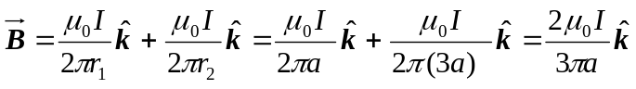.
c) At the same distance as part (b), but below the lower wire, yields the same magnitude magnetic field but in the opposite direction: 

